Unit 4.1 Graded Assignment
Name: Mohammad Hamza Asim
Employee #: 2303.KHI.DEG.014
Collaborated with: Saad Sameer Khan(2303.KHI.DEG.034)

docker-compose.yaml
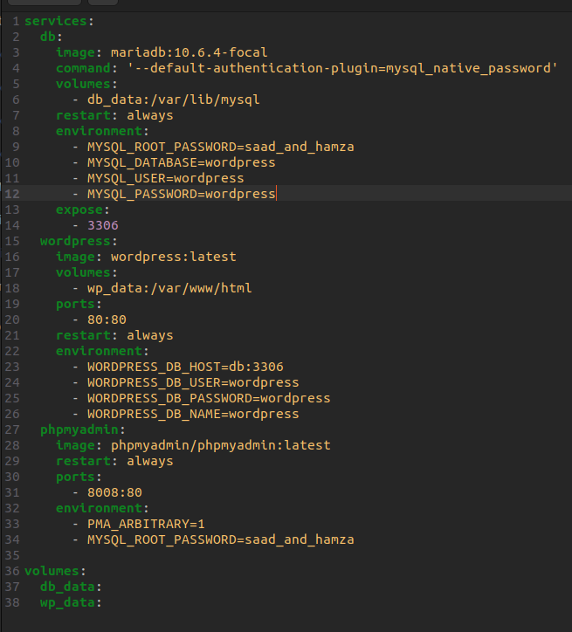
Above, we have defined 3 services; mariaDB, wordpress, and phpadmin.

MariaDB
- MariaDB holds the database that contains user information such as email and password.
- In the environment variables we have set MYSQL_DATABASE, MYSQL_USER, MYSQL_PASSWORD, which specify the name of the database, the user-name and password that wordpress will use for accessing and adding to the databse.
- MYSQL_ROOT_PASSWORD specifies the password that phpadmin can use to have root access to the database.
- To allow Wordpress and phpadmin to communicate with MariaDB, we have exposed its port at 3306.

Wordpress
- Wordpress communicates with mariaDB when it wants to log in users and wants to access the user info database in mariaDB. Also when it creates new users, which will be stored in the database at mariaDB.
- We provide it the same variables with the same values as we did in mariaDB, to allow it access to the database.
- To view the UI of wordpress we have bound it to port 80 of our host machine to allow access at http://127.0.0.1/.
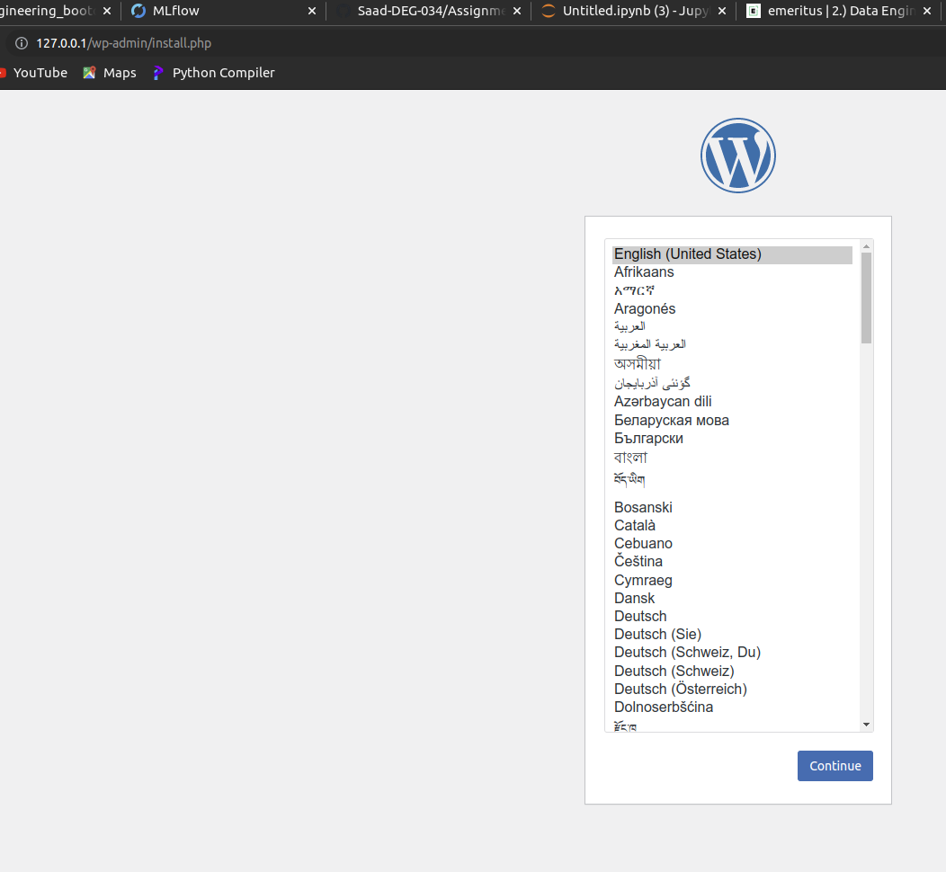

phpadmin
- Phpadmin can alter the user database created in mariaDB.
- To give it root access to mariaDB, we provide it the root password we defined in mariaDB service.
- To access its UI, we bind it to port 8008 of our host machine.

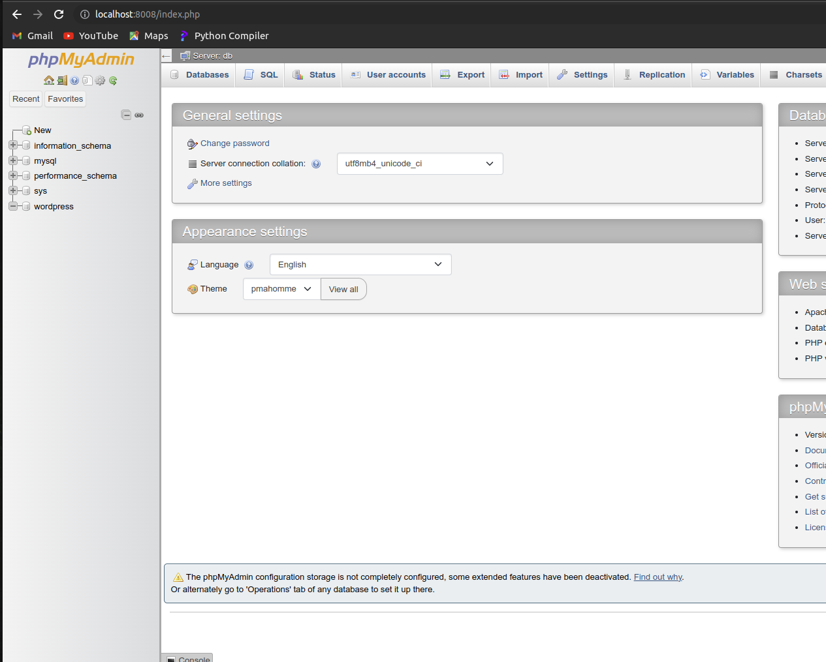

Docker-compose Logs:
Viewing the logs being created by docker-compose
